Chapter 33 – Aggregate Demand and Aggregate Supply
Principles of Economics (8th Edition) – N. Gregory Mankiw | Study Notes

Introduction
Economies do not grow at a steady rate every year. Output, income, and employment go up and down over time. This chapter introduces the model of aggregate demand (AD) and aggregate supply (AS), which economists use to explain these short-run ups and downs, called economic fluctuations or the business cycle.
A period of falling output is called a recession. A very severe recession is called a depression. This model helps us understand why these fluctuations happen and how the price level and total output move together.

Three Key Facts about Economic Fluctuations
Before building the model, it is useful to know three basic facts that describe how real economies behave.
- Fact 1: Economic fluctuations are irregular and unpredictable. Recessions do not follow a fixed pattern or schedule.
- Fact 2: Most macroeconomic variables move together. When GDP falls, income, spending, and production also fall. Investment spending swings the most.
- Fact 3: As output falls, unemployment rises. When firms produce less, they hire fewer workers.
Exam focus: Remember the three facts in order — irregular fluctuations, variables move together, and unemployment rises when output falls.
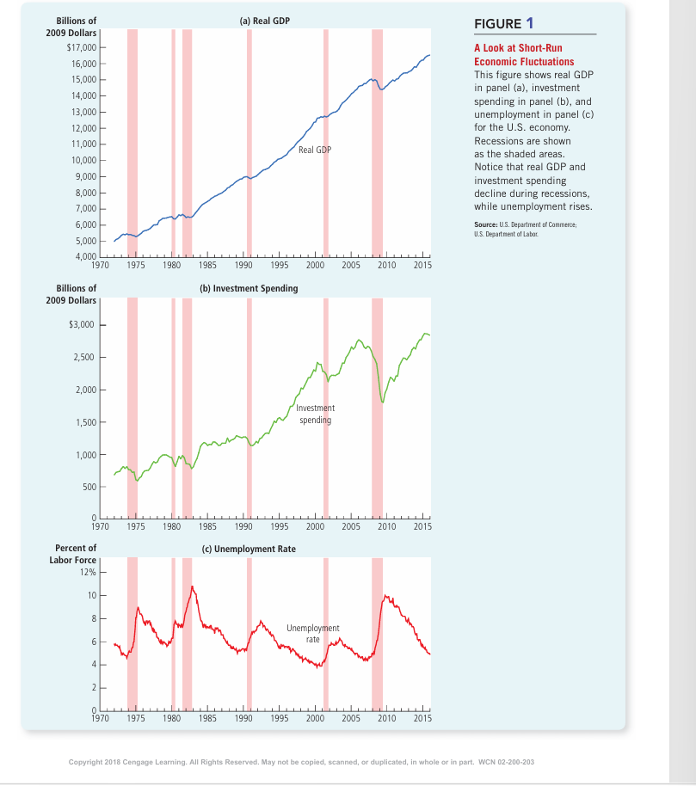

Classical Economics and Its Limits
Classical economic theory rests on the classical dichotomy — the idea that real variables (output, employment) and nominal variables (price level, money supply) can be studied separately. This leads to monetary neutrality: changes in money supply affect prices but not real output.
Most economists agree this is true in the long run, but not in the short run. In the short run, real and nominal variables are closely linked. This is why we need a separate model — aggregate demand and aggregate supply — to study short-run fluctuations.

The Model of Aggregate Demand and Aggregate Supply
This model has two variables: the price level (vertical axis) and real GDP / total output (horizontal axis). The aggregate-demand curve shows the quantity of goods and services that households, firms, the government, and foreign buyers want to buy at each price level. The aggregate-supply curve shows the quantity that firms produce and sell at each price level.
Equilibrium output and the price level are set where the AD and AS curves cross. This model looks similar to ordinary demand and supply, but it works differently, because it deals with the entire economy, not one single market.
📌 Diagram Required
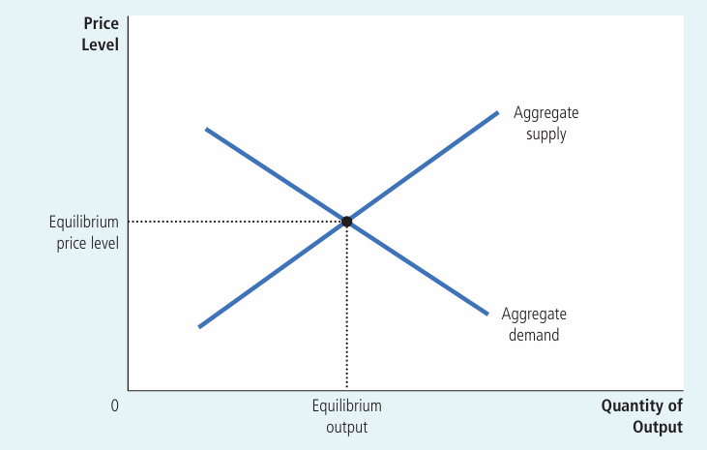
Figure: Aggregate Demand and Aggregate Supply
What the graph shows: The overall price level on the vertical axis and total output of the economy on the horizontal axis.
Curves/lines: The aggregate-demand curve slopes downward; the aggregate-supply curve is shown crossing it at the equilibrium price level and equilibrium output.
Why it matters: This is the basic framework used throughout the chapter to explain recessions, booms, and inflation.
Exam tip: Remember: this is NOT the same as market demand and supply from Chapter 4 — it applies to the whole economy, so resources cannot simply shift between markets.

Aggregate Demand (AD)
The aggregate-demand curve shows the total quantity of goods and services demanded in the economy at each price level. It always slopes downward: a lower price level increases the quantity of goods and services demanded, and a higher price level reduces it.
GDP is made up of four spending components: Y = C + I + G + NX (consumption, investment, government purchases, net exports). Government spending is usually fixed by policy, so the downward slope comes from how the price level affects consumption, investment, and net exports.

Why the Aggregate-Demand Curve Slopes Downward
There are three separate reasons, each linked to one part of GDP.
- 1. The Wealth Effect (Consumption): A lower price level raises the real value of the money people hold. People feel wealthier, so they spend more. This raises consumption.
- 2. The Interest-Rate Effect (Investment): A lower price level means people need to hold less money for daily purchases. They lend out the extra money, which lowers interest rates. Lower interest rates encourage firms and households to borrow and invest more.
- 3. The Exchange-Rate Effect (Net Exports): Lower interest rates make investors move money abroad. This raises the supply of dollars in currency markets, so the dollar depreciates. A weaker dollar makes U.S. goods cheaper for foreigners and foreign goods costlier for Americans, so net exports rise.
Example: If the price level falls, your savings can buy more (wealth effect), banks lower loan interest rates (interest-rate effect), and Bangladeshi exporters find it cheaper to sell abroad if their currency weakens (exchange-rate effect). All three push total spending up.
Exam tip: These three effects only work through the price level. The AD curve is drawn assuming the money supply is constant.
📌 Diagram Required
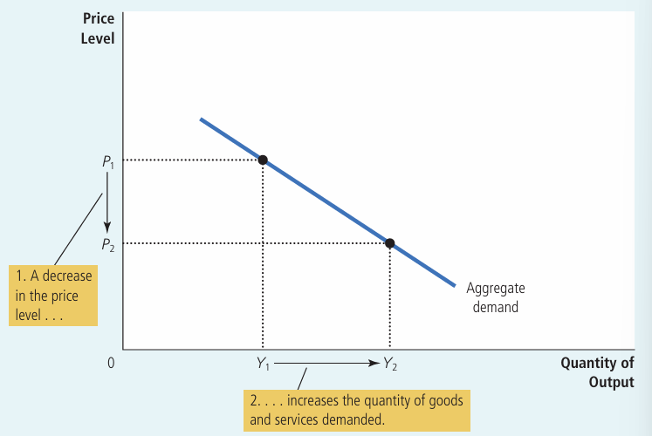
Figure: The Aggregate-Demand Curve
What the graph shows: The price level is on the vertical axis and total output is on the horizontal axis. The curve shows how quantity of output demanded changes as the price level changes.
Curves/lines: A single downward-sloping curve labeled 'Aggregate demand'. A fall in price level from P1 to P2 raises quantity demanded from Y1 to Y2.
Why it matters: It shows the basic negative relationship between the price level and total quantity of goods and services demanded.
Exam tip: In exams, be ready to label P1, P2, Y1, Y2 and explain the movement using the three effects above.

Shifts in Aggregate Demand
A movement along the AD curve happens only because of a price-level change. Any other event changes the entire position of the curve — this is called a shift in aggregate demand.
- Changes in Consumption: Tax cuts, stock market booms, or optimism raise consumption and shift AD right. Tax hikes or pessimism shift AD left.
- Changes in Investment: New technology, business optimism, or a rise in money supply (lower interest rates) shift AD right. Pessimism or a fall in money supply shift AD left.
- Changes in Government Purchases: More government spending (defense, infrastructure) shifts AD right. Spending cuts shift AD left.
- Changes in Net Exports: A foreign boom or a weaker dollar raises net exports and shifts AD right. A foreign recession or a stronger dollar shifts AD left.
Real-life example: During a global recession, other countries buy fewer goods from Bangladesh's export industries. This lowers net exports and shifts Bangladesh's aggregate demand to the left.
Exam tip: Always ask — does this event change spending at a given price level? If yes, it shifts the AD curve; it does not just move along it.

Aggregate Supply
The aggregate-supply curve shows the total quantity of goods and services that firms produce and sell at each price level. Unlike AD, its shape depends on the time horizon: it is vertical in the long run and slopes upward in the short run.

Long-Run Aggregate Supply (LRAS)
In the long run, an economy's output depends only on its supplies of labor, capital, natural resources, and technology — not on the price level. This output level is called the natural level of output (also called potential or full-employment output).
Why LRAS is vertical: Since the price level (a nominal variable) does not affect real output in the long run, the LRAS curve is a straight vertical line at the natural level of output. This reflects the classical dichotomy and monetary neutrality.
📌 Diagram Required
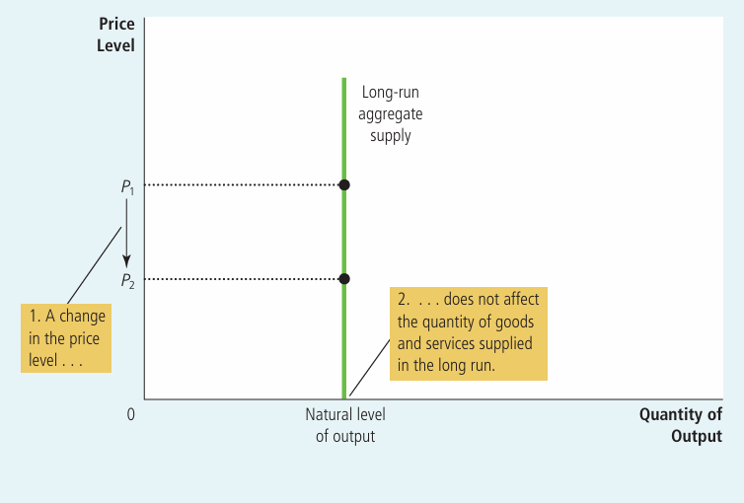
Figure: The Long-Run Aggregate-Supply Curve
What the graph shows: A vertical line showing that output supplied stays the same no matter what the price level is.
Curves/lines: One vertical curve labeled 'Long-run aggregate supply', positioned at the natural level of output on the horizontal axis.
Why it matters: It shows that in the long run, only real factors (not money or prices) determine total output.
Exam tip: A common exam question asks you to explain WHY this curve is vertical — always mention labor, capital, natural resources, and technology.
Shifts in LRAS: Because LRAS depends on the four real factors of production, any change in these shifts the curve.
- Labor: More workers (immigration, lower natural unemployment) shift LRAS right; fewer workers shift it left.
- Capital: More physical or human capital (machines, education) shifts LRAS right; less capital shifts it left.
- Natural Resources: Discovery of new resources shifts LRAS right; depletion or supply disruption shifts it left.
- Technology: New inventions and knowledge shift LRAS right; harmful regulations can shift it left.

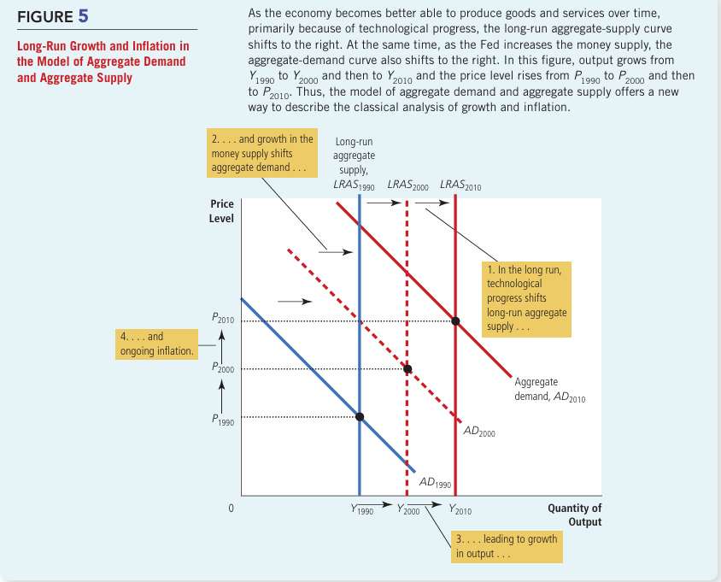

Short-Run Aggregate Supply (SRAS)
In the short run, the price level does affect output. A higher price level raises the quantity of goods and services supplied, and a lower price level reduces it. This gives the SRAS curve an upward slope.
📌 Diagram Required
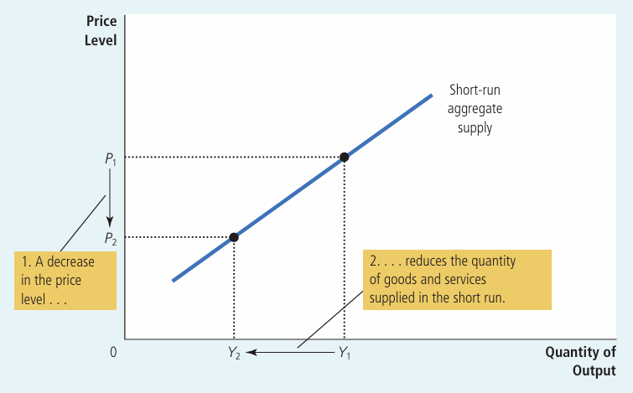
Figure: The Short-Run Aggregate-Supply Curve
What the graph shows: An upward-sloping curve showing that a fall in the price level reduces output supplied in the short run.
Curves/lines: One upward-sloping curve labeled 'Short-run aggregate supply'. A fall in price level from P1 to P2 reduces output from Y1 to Y2.
Why it matters: It shows that firms respond to price changes in the short run, unlike in the long run.
Exam tip: Remember this relationship is only temporary — over time wages, prices, and expectations adjust.
Why SRAS slopes upward — Three Theories:
- 1. Sticky-Wage Theory: Nominal wages are fixed by contracts for a period of time. If the price level falls unexpectedly, real wages rise, making labor costlier, so firms cut production. This is the theory emphasized most in this book.
- 2. Sticky-Price Theory: Some firms are slow to change prices because of menu costs (cost of updating price lists). If the price level falls and a firm's price stays too high, its sales fall, so it cuts production.
- 3. Misperceptions Theory: Suppliers may confuse a fall in the overall price level with a fall in their own relative price. Thinking their product is less rewarding to produce, they cut back output.
Key formula: Quantity of output supplied = Natural level of output + a × (Actual price level − Expected price level), where 'a' shows how strongly output reacts to unexpected price changes.
Exam tip: All three theories share one idea — output differs from its natural level only when the actual price level differs from the expected price level. This gap disappears over time, which is why SRAS becomes vertical in the long run.

Shifts in Short-Run Aggregate Supply
Anything that shifts LRAS (labor, capital, natural resources, technology) also shifts SRAS in the same direction. In addition, SRAS shifts because of one extra factor:
- Expected Price Level: A rise in the expected price level leads to higher wages/prices being set in advance, raising costs and shifting SRAS left. A fall in the expected price level shifts SRAS right.
Example: If firms and workers expect high inflation next year, they agree to higher wages today. This raises production costs at every price level, shifting SRAS to the left.

Long-Run Equilibrium
The economy is in long-run equilibrium where the aggregate-demand curve crosses the long-run aggregate-supply curve. At this point, output is at its natural level, and because expectations have adjusted, the short-run aggregate-supply curve also passes through the same point.
📌 Diagram Required
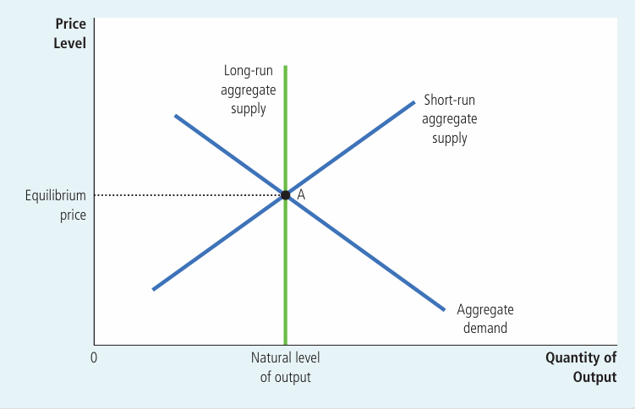
Figure: The Long-Run Equilibrium
What the graph shows: The point where AD, SRAS, and LRAS all cross together.
Curves/lines: Aggregate demand, short-run aggregate supply, and long-run aggregate supply — all three curves meeting at one equilibrium point.
Why it matters: It represents a stable economy where the expected price level equals the actual price level.
Exam tip: In exams, always start any AD-AS shock question by drawing this three-curve long-run equilibrium first.
Four steps to analyze any economic fluctuation (very important for exams):
- Step 1: Decide whether the event shifts AD, SRAS, or both.
- Step 2: Decide the direction of the shift (left or right).
- Step 3: Compare the new short-run equilibrium with the old one to find the short-run effect on output and prices.
- Step 4: Trace how the economy moves from the new short-run equilibrium to a new long-run equilibrium.

Two Causes of Economic Fluctuations
Economic fluctuations happen because of shifts in either aggregate demand or aggregate supply. Each type of shock has a different effect on output and prices.

Demand Shocks
A demand shock is an event that shifts the aggregate-demand curve. Example: a wave of pessimism (bad news, stock market crash, war fears) reduces spending on consumption and investment.
📌 Diagram Required
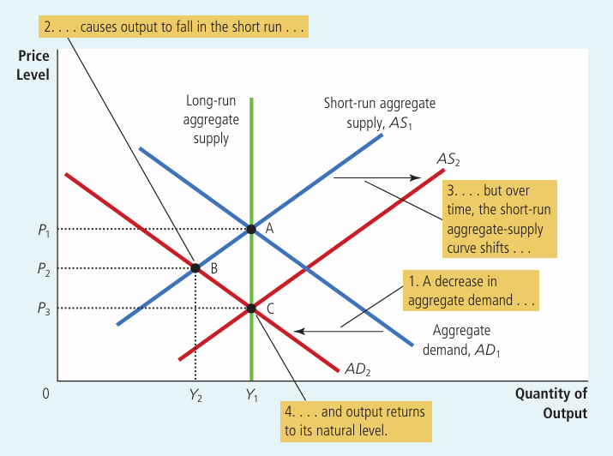
Figure: A Contraction in Aggregate Demand
What the graph shows: A leftward shift of the AD curve and its effect on output and prices, both in the short run and long run.
Curves/lines: AD1 shifts left to AD2. Short-run aggregate supply (AS1) stays the same at first, then shifts right to AS2 as expectations adjust. LRAS is vertical throughout.
Why it matters: It shows that AD shocks affect output only in the short run — in the long run, only prices change.
Exam tip: This is one of the most commonly tested diagrams — practice labeling points A (initial), B (short-run), and C (new long-run equilibrium).
Recessionary Gap: When aggregate demand falls, the economy moves to a short-run equilibrium where output is below its natural level. This shortfall in output is called a recessionary gap. It shows up as rising unemployment.
How the economy self-corrects: As people revise their price expectations downward, wages and prices adjust, and SRAS shifts right. Over time, output returns to its natural level, but at a permanently lower price level. This is a real-life example of monetary neutrality in the long run — money affects prices, not output, once the economy fully adjusts.
Inflationary Gap (Expansionary case): If aggregate demand instead increases — for example, due to a wave of optimism or a big rise in government spending — output rises above its natural level in the short run. This is called an inflationary gap (or expansionary gap). Over time, rising costs push SRAS left, and the economy returns to its natural output level, but at a higher price level.
Real-life example: During World War II, huge government spending pushed U.S. output far above normal and raised prices — a clear case of an inflationary gap caused by a demand shock.
- In the short run, AD shifts change output (recession or boom).
- In the long run, AD shifts change only the price level, not output.
- Because policymakers can influence AD, they can potentially reduce the length and severity of these swings.

Supply Shocks
A supply shock is an event that shifts the short-run aggregate-supply curve. A common cause is a sudden rise in production costs — for example, a spike in oil prices.
📌 Diagram Required
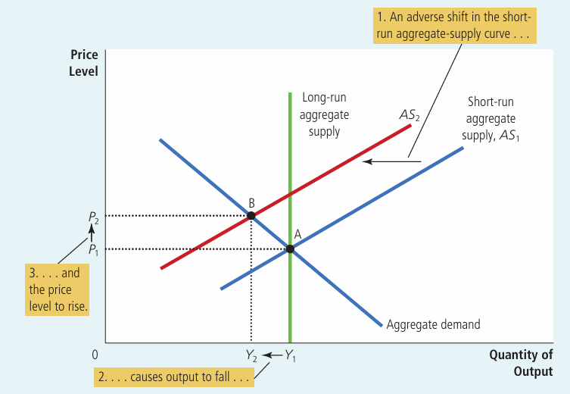
Figure: An Adverse Shift in Aggregate Supply
What the graph shows: A leftward shift of the SRAS curve and its effect on output and the price level.
Curves/lines: SRAS shifts left from AS1 to AS2. The economy moves from point A to point B: output falls and the price level rises at the same time.
Why it matters: It shows how a supply shock can cause both recession and inflation together, unlike a demand shock.
Exam tip: Learn the term stagflation — falling output plus rising prices — this is a favorite exam keyword.
Stagflation is the combination of recession (falling output) and inflation (rising prices), caused by an adverse supply shock. It is more difficult for policymakers to handle than a demand shock, because fighting inflation worsens unemployment, and fighting unemployment worsens inflation.
Real-life example: In the 1970s, OPEC oil-price increases raised production costs worldwide. Many economies suffered stagflation — high unemployment together with high inflation.
- Adverse supply shock: SRAS shifts left → output falls, price level rises → stagflation.
- Favorable supply shock: SRAS shifts right → output rises, price level falls (e.g., oil prices dropping).

Stabilization Policy (Policy Responses)
Policymakers can use monetary and fiscal policy to influence aggregate demand and reduce the impact of economic fluctuations.
- Responding to a demand shock: If AD falls and causes a recession, policymakers can raise government spending or increase the money supply to shift AD back to the right, restoring output faster.
- Responding to a supply shock (Accommodative Policy): Policymakers can shift AD to the right to offset a leftward SRAS shift. This keeps output at its natural level but permanently raises the price level.
📌 Diagram Required
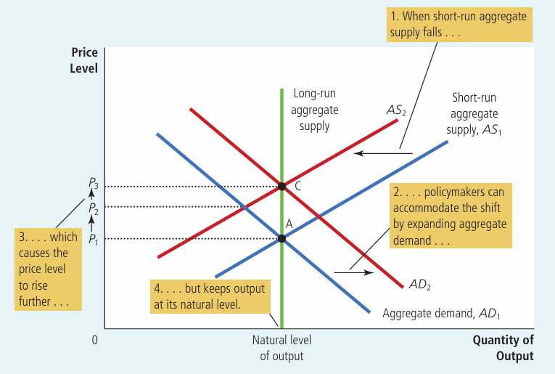
Figure: Accommodating an Adverse Shift in Aggregate Supply
What the graph shows: How policymakers can respond to a supply shock by shifting aggregate demand.
Curves/lines: SRAS shifts left from AS1 to AS2. Policymakers then shift AD right from AD1 to AD2, moving the economy from point A directly to point C.
Why it matters: It shows the trade-off in accommodative policy: output stays at its natural level, but the price level rises permanently.
Exam tip: Be ready to explain the trade-off: accommodating a supply shock avoids a recession but locks in higher prices.
Exam tip: A supply shock forces a trade-off between output and prices. A demand shock does not — both output and prices move in the same direction (both fall in a demand-driven recession).

Summary
- All economies experience irregular, short-run fluctuations around their long-run growth trend.
- Classical theory (money is neutral) works in the long run but not the short run, which is why the AD-AS model is needed.
- The AD curve slopes downward because of the wealth effect, interest-rate effect, and exchange-rate effect.
- AD shifts because of changes in consumption, investment, government purchases, or net exports.
- The LRAS curve is vertical at the natural level of output because prices do not affect real output in the long run.
- The SRAS curve slopes upward due to sticky wages, sticky prices, or misperceptions — all temporary effects.
- SRAS shifts due to changes in labor, capital, natural resources, technology, or the expected price level.
- A demand shock changes output in the short run but only prices in the long run (recessionary or inflationary gap).
- A supply shock can cause stagflation — falling output with rising prices.
- Policymakers can use monetary and fiscal policy to offset demand shocks, or to accommodate supply shocks at the cost of higher prices.

Important Exam Points
- Always draw and label three curves together: AD, SRAS, and LRAS.
- Know the three reasons for AD's downward slope: wealth, interest-rate, exchange-rate effects.
- Know the three theories for SRAS's upward slope: sticky wages, sticky prices, misperceptions.
- LRAS is vertical because output depends only on labor, capital, resources, and technology — not price level.
- Demand shock → output and price level move in the same direction (both fall or both rise).
- Supply shock → output and price level move in opposite directions → stagflation or its reverse.
- Recessionary gap = output below natural level; Inflationary gap = output above natural level.
- In the long run, all fluctuations self-correct back to the natural level of output — only the price level changes permanently.
- Accommodative policy avoids recession from a supply shock, but raises prices permanently — a key trade-off to explain in essays.
- Use the four-step method (identify curve → direction → short-run effect → long-run adjustment) to answer any AD-AS fluctuation question.

